In essay form, critically discuss this quotation from different points of view and provide your conclusion.

“Validity means that our diagnostic categories describe real entities and not flawed concepts”

Reference: Crocq MA. Can psychopathology and neuroscience coexist in psychiatric classifications?. Dialogues in clinical neuroscience. 2022 Apr 1.

10%

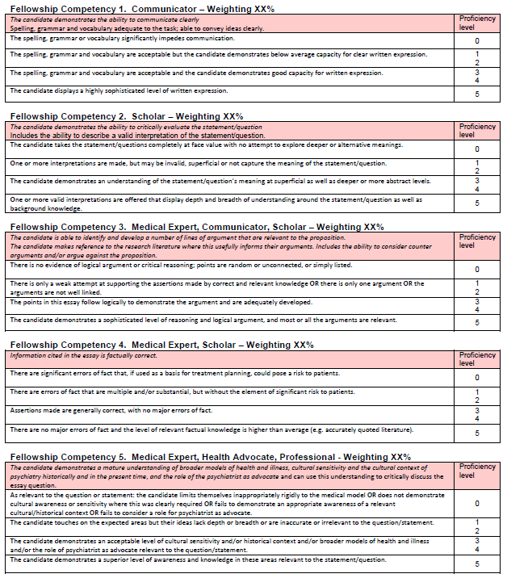

20%

30%

20%
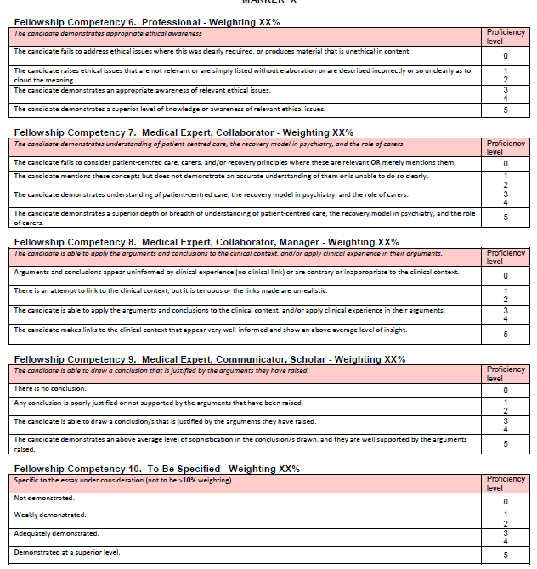

20%

